Introduction to Database Systems (CSD317)

Practice Lab#9

1. Create a database PL9 and use it.

4. Write a PL/SQL block to Create an explicit cursor to display the details of all teams ROW BY ROW.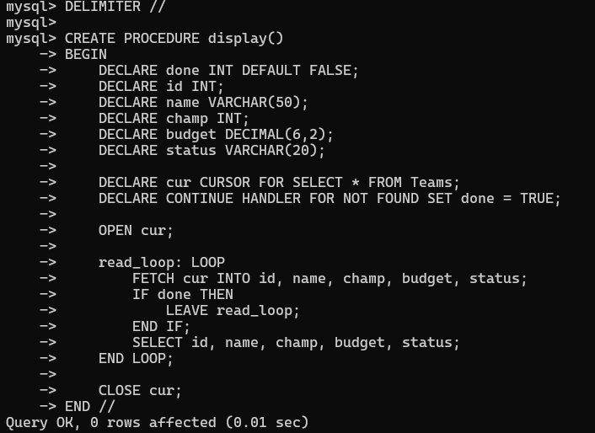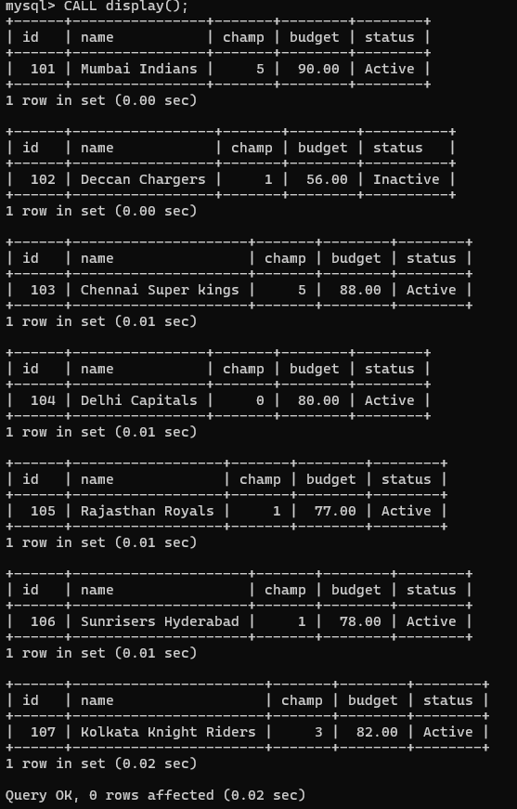

6. Create a stored procedure that uses a cursor to fetch and display teams and their respective budget where Budget > 80.00.

7. Update name of team Chennai Super Kings to CSK without starting the transaction, rollback it and display the table.

8. Now start the transaction, set auto commit as 0. Delete the record where TeamID is 104 and rollback it. Observe the difference before starting a transaction and after starting a transaction. A screenshot of a computer

9. Delete the record where TeamID is 106 after starting the transaction, commit the transaction and rollback it. Observe the difference before and after committing the transaction.

10. Start transaction. Add a new team with all the details into the table(any of your choice) and save it as savepoint s1. Now add one more team and save it as savepoint s2. Now rollback the transaction to s1. Display table after every operation to know the differences created in the table. 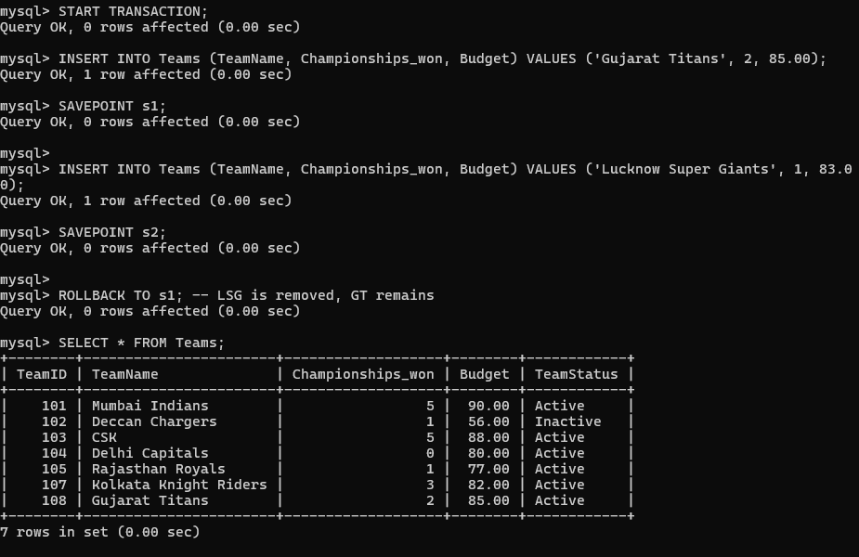

11. Open one more SQL window and use the same database. Start transaction in both windows and set auto commit as 0 in both windows. Insert a new record in window 1, Insert another (new) record in window 2 & display the table before committing and after committing in each window.

12) Update any record from table in window1 and update the same record in window2 at the same time (before commit in window 1).

